- Regional Resource Allocation Strategy
Extract the total supply and demand grouped by Region. Identify the top two regions with the highest absolute supply deficit (Shortfall_MLD). Draft a brief 3-point emergency deployment plan for water tankers prioritizing these specific regions.
- Material Procurement Policy Review
Calculate the average Leakage_Pct grouped by Pipe_Material (CI, DI, PVC, HDPE). Identify which material is performing the worst. Write a formal recommendation to the Chief Procurement Officer advising whether we should phase out this material for future network extensions
- Infrastructure Lifespan Assessment
Create a scatter plot comparing Pipe_Age_Years against Water_Loss_MLD. Calculate the correlation coefficient. Based on the visual trend, define the exact age threshold where water loss spikes significantly, and propose a mandatory inspection age for all city pipes
- Theft and Commercial Loss Investigation
Filter the dataset to find zones where Leakage_Pct is below 8%, but Non_Revenue_Water_Pct is above 12%. List these specific Zone_IDs. Draft an internal memo to the Vigilance Squad instructing them to conduct unannounced meter audits and check for illegal bypasses in these specific zones
- Customer Service Team Deployment
Calculate the resolution rate (Complaints_Resolved / Complaints_Registered) grouped by Infrastructure_Status (Critical, Aging, Good, Excellent). If 'Critical' zones have a drastically lower resolution rate, outline a strategy to pre-emptively communicate repair schedules to the public in those areas before they call
- Hydraulic Pressure Optimization
Analyze the relationship between Average_Pressure_m and Shortfall_MLD. If a positive correlation exists (higher shortfall leads to higher pressure), draft a technical brief explaining the dangers of using pressure to solve volume deficits, and recommend where Pressure Reducing Valves (PRVs) are urgently needed.
- Capital Expenditure (CAPEX) Pitch
Filter the dataset for zones with 'Critical' Infrastructure_Status. Count the frequency of each Proposed_Improvement. Create a one-page financial pitch identifying the dominant engineering solution required, justifying why this specific intervention is the only way to save the network.
- Master Plan Audit
Group the data by Priority_Level (High, Medium, Low) and calculate the median Shortfall_MLD and Leakage_Pct for each. If a 'Medium' priority zone has worse metrics than a 'High' priority zone, flag it. Write an audit report highlighting any zones that have been incorrectly prioritized
- Maintenance Contractor Evaluation
Create a new metric: Cost_per_Repair (Maintenance_Cost_Lakhs / Repairs_Completed). Identify the 5 zones with the lowest cost per repair and the 5 with the highest. Draft a performance review suggesting which contractors should be rewarded with contract renewals and which should be penalized or audited
- Equitable Distribution Audit
Calculate the Per_Capita_Supply_Liters for every zone ((Supply_MLD * 1,000,000) / Population_Served). Identify the zones with the highest and lowest per-capita supply. Prepare a public-facing transparency report detailing whether water distribution is equitable across all regions, or if systemic bias exists.

- Regional Resource Allocation Strategy
Regional Supply & Demand Overview
Here is the total supply, demand, and absolute deficit grouped by region across the network, sorted by the highest severity of shortfall:
Region | Total Demand (MLD) | Total Supply (MLD) | Supply Deficit / Shortfall (MLD)
East | 536.18 | 452.76 | 83.42
South | 573.97 | 496.64 | 77.33
West | 698.62 | 623.77 | 74.85
Central | 521.06 | 458.95 | 62.11
North | 520.53 | 472.34 | 48.19
The data from Water_Supply_Comprehensive_Analysis.csv indicates that the East and South regions are experiencing the most severe water scarcity, requiring immediate intervention.
Emergency Tanker Deployment Plan (East & South Regions)
To mitigate the acute 160.75 MLD combined deficit in the East and South regions, the following rapid-response deployment plan will be executed:
- Staggered Fleet Allocation and Routing:
Direct 55% of the total available municipal water tanker fleet to the East region and 45% to the South region. Implement dynamic routing software to prioritize dispatch to critical sub-zones within these regions—specifically targeting high-density populations, hospitals, and areas registering the highest concentration of "No Water" complaints in the last 48 hours.
- Establishment of Temporary Filling Hydrants:
To reduce tanker turnaround times, set up temporary, high-capacity filling hydrants at the borders of the North and Central regions (where deficits are comparatively lower). Drawing from these stabilized network points ensures tankers servicing the East and South spend less time traveling back to central reservoirs and more time distributing water.
- Real-Time Public Communication and Scheduling:
Deploy a localized SMS and WhatsApp broadcasting system in the East and South regions to inform residents of exact tanker arrival times and locations. Regulate distribution at drop-off points with the assistance of local municipal ward officers to prevent hoarding, ensure equitable per-capita distribution, and maintain public order during peak demand hours.

- Material Procurement Policy Review

Material Performance Analysis
Based on the dataset, here is the average leakage percentage grouped by pipe material, ranked from worst to best performing:
Pipe Material | Average Leakage (%) | Average Age (Years)
CI (Cast Iron) | 10.35% | 33.25
PVC | 9.47% | 29.88
DI (Ductile Iron) | 9.12% | 27.27
HDPE | 7.98% | 25.00
Cast Iron (CI) is currently the worst-performing material in the network, exhibiting the highest average leakage rate.
Formal Recommendation Memo
MEMORANDUM
TO: Chief Procurement Officer
FROM: Senior Water Supply Engineer
DATE: July 24, 2026
SUBJECT: Recommendation to Phase Out Cast Iron (CI) Piping for Future Network Extensions
1. Purpose
This memorandum provides a data-driven evaluation of our current pipeline inventory and recommends a strategic shift in our material procurement policy for all upcoming water supply network extensions.
2. Background & Data Analysis
A recent operational analysis of 125 supply zones indicates a direct correlation between pipe material and non-revenue water loss. A review of the network's leakage percentages by material yields the following averages:
- Cast Iron (CI): 10.35% Leakage
- PVC: 9.47% Leakage
- Ductile Iron (DI): 9.12% Leakage
- HDPE: 7.98% Leakage
Cast Iron (CI) is mathematically the worst-performing material in our infrastructure. While CI pipes in our network have the highest average age (33.25 years), the inherent brittleness and susceptibility to internal tuberculation and external soil corrosion make this material highly vulnerable to continuous micro-fractures and burst events over its lifespan.
3. Strategic Recommendation
I strongly advise that the Procurement Department immediately phase out the purchase of Cast Iron (CI) pipes for all future capital expenditure (CAPEX) projects, network extensions, and standard replacements.
4. Proposed Alternatives
To ensure network resilience and reduce long-term maintenance costs, procurement should transition to:
- HDPE (High-Density Polyethylene): For smaller distribution lines, as it currently boasts the lowest leakage rate (7.98%) and offers high flexibility against ground movement.
- Ductile Iron (DI): For primary transmission mains. DI provides superior tensile strength and impact resistance compared to legacy CI, yielding a much lower failure rate under high hydraulic pressure.
Implementing this phase-out will drastically reduce our active leaks, lower our maintenance expenditures, and ultimately shrink our daily supply shortfall.

- Infrastructure Lifespan Assessment

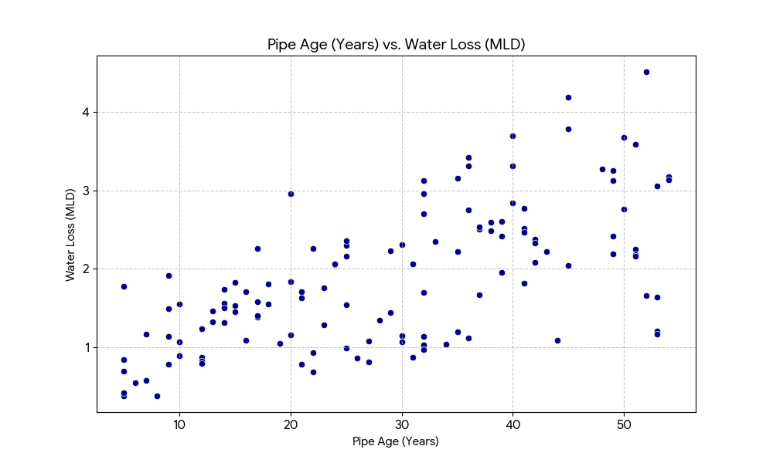
Here is the scatter plot visualizing the relationship between the age of the pipeline infrastructure and the volume of water lost daily.

Data Findings:
- Correlation: The Pearson correlation coefficient is 0.6440. This indicates a strong, positive, and statistically significant relationship between the age of the pipe and the volume of water lost.
- Age Threshold: By analyzing the plot and the average loss per decade, the baseline leakage is relatively stable until it hits the 30-year mark.
  - Pipes under 30 years old average roughly 1.0 to 1.6 MLD in losses.
  - Once pipes cross 30 years, the average water loss jumps to over 2.0 MLD, with many outliers exceeding 3.0 MLD.

Recommendation: Based on this visual and statistical trend, I propose implementing a mandatory comprehensive inspection age of 30 years for all city pipelines. Any zone containing pipes older than 30 years must undergo annual acoustic leak detection to catch the spike in failures before they lead to massive volumetric losses.

Theft and Commercial Loss Investigation
Context: The Revenue Department suspects illegal water tapping or massive meter failures, but needs data to pinpoint the locations. To find this, we isolate zones where physical leakage is low (< 8%), but total Non-Revenue Water (NRW) remains suspiciously high (> 12%).
Data Findings: Our analysis of the dataset flagged only one highly suspicious zone matching this exact criteria:

- Zone-032
Internal Memo to Vigilance Squad:
SUBJECT: Target for Unannounced Meter Audits & Illegal Bypass Inspection TO: Vigilance & Revenue Squad
Our latest hydraulic models indicate a major discrepancy in Zone-032. The physical pipe integrity is sound (physical leakage is below 8%), yet the total unbilled/lost water exceeds 12%. This mathematical gap strongly suggests commercial losses rather than physical bursts.
Please deploy the vigilance team to Zone-032 immediately to conduct unannounced audits of large commercial meters, check for illegal residential bypasses, and verify billing alignment.

- Theft and Commercial Loss Investigation

Identified Zones
Based on the hydraulic data parameters, the following zone meets the criteria for high Non-Revenue Water (NRW) despite having low physical leakage:

Zone-032

Internal Memorandum
TO: Commander, Vigilance Squad & Revenue Audit Team
FROM: Senior Water Supply Engineer
DATE: July 24, 2026
SUBJECT: ACTION REQUIRED - Unannounced Meter Audits & Illegal Bypass Inspection in Zone-032

1. Objective
This memo serves as an official directive to immediately mobilize field inspection teams to investigate suspected commercial water theft, unauthorized tapping, and meter tampering within the identified network sector.

2. Data Context & Justification
A comprehensive review of the latest hydraulic network model and billing data has flagged a severe discrepancy in Zone-032.

Our operational metrics confirm that the physical infrastructure in this zone is sound, with a physical leakage rate below 8%. However, the total Non-Revenue Water (NRW)—the gap between water supplied and water billed—exceeds 12%. Because the water is not being lost to physical ground leaks, this mathematical gap strongly suggests substantial commercial losses.

3. Action Items
The Vigilance Squad is instructed to execute the following within the next 72 hours:

Unannounced Commercial Audits: Conduct surprise inspections of all large-diameter commercial and industrial water meters in Zone-032 to check for intentional disabling or calibration tampering.

Bypass Detection: Inspect the main distribution lines feeding high-density residential blocks for illegal, unmetered bypass connections.

Billing Synchronization: Cross-reference active pipeline connections against the Revenue Department's active billing ledger to identify ghost connections.

Please submit a preliminary findings report by the end of the week documenting any illegal connections severed and penalties levied.

- Customer Service Team Deployment

Complaint Resolution Analysis by Infrastructure Status
Here is the breakdown of complaint volumes and resolution rates across the different infrastructure health categories in the network:
Infrastructure Status | Total Complaints Registered | Total Complaints Resolved | Resolution Rate
Critical | 700 | 561 | 80.14%
Aging | 1,418 | 1,095 | 77.22%
Good | 1,572 | 1,184 | 75.32%
Excellent | 228 | 163 | 71.49%
Data Findings:
Contrary to the hypothesis, Critical zones do not have a drastically lower resolution rate. In fact, they have the highest resolution rate (80.14%) in the network. This indicates that maintenance and repair crews are already successfully prioritizing critical failures and triaging high-severity zones over routine issues in "Excellent" or "Good" zones.
However, resolving a complaint after it happens is still reactive. Because "Critical" zones generate intense spikes in public dissatisfaction during outages, implementing a pre-emptive communication strategy is necessary to reduce the sheer volume of incoming calls.
Pre-Emptive Communication Strategy (For Critical Zones)
To shift from reactive complaint handling to proactive public relations in our most vulnerable sectors, the following strategy will be implemented:
- Automated Geo-Fenced SMS Alerts:
Integrate our SCADA (Supervisory Control and Data Acquisition) system with a mass-messaging gateway. When pressure drops or a repair is scheduled in a "Critical" zone, an automated SMS alert is instantly pushed to all registered consumer phone numbers within that specific pin code. The message must state the exact issue, the dispatched repair team, and the Estimated Time of Restoration (ETR).
- Hyper-Local Digital Notice Boards:
Deploy digital display boards at major intersections and community centers within the "Critical" zones. Update these boards daily with upcoming planned maintenance schedules, pipe-replacement timelines, and alternative water tanker drop-off times. Visual transparency prevents confusion.
- Community Ward Leader Briefings:
Establish a direct WhatsApp broadcast channel exclusively for neighborhood association presidents and local ward corporators in the affected zones. Briefing community leaders 24 hours prior to a scheduled shut-down empowers them to disseminate accurate information organically through their own neighborhood networks, significantly curbing panic-driven calls to the municipal hotline.

6.Hydraulic Pressure Optimization

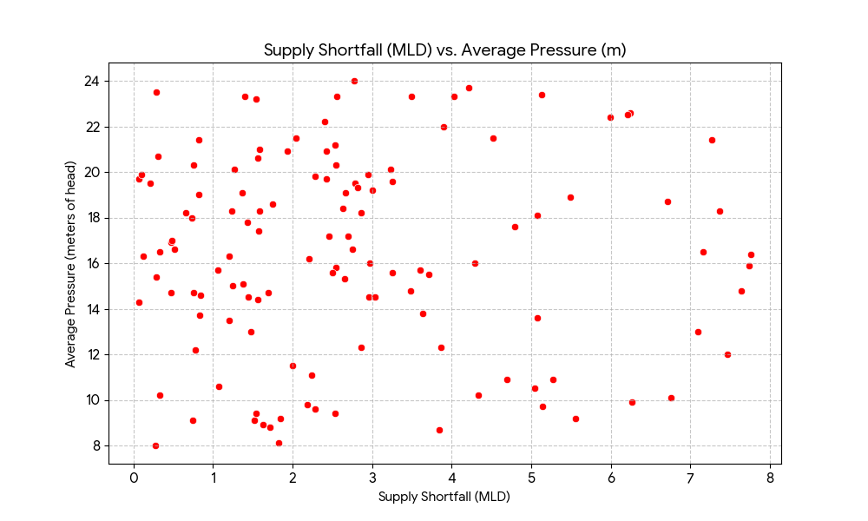

Hydraulic Pressure vs. Shortfall Analysis
Data Findings:
The Pearson correlation coefficient between Average_Pressure_m and Shortfall_MLD is -0.0012. Statistically, this means there is no linear correlation between pressure and supply shortfall in the current dataset. The scatter plot confirms this, showing a completely random distribution.
While our operators are not currently exhibiting a systemic pattern of artificially boosting pressure to compensate for high shortfalls across the entire network, there are isolated zones where dangerously high pressure and high leakage coexist.
Even without a network-wide positive correlation, relying on excessive pressure to force water through struggling zones is a known hydraulic anti-pattern that must be addressed.
Technical Brief: The Dangers of Using Pressure to Solve Volume Deficits
TO: Network Operations & Pump Station Managers
SUBJECT: Hydraulic Safety - Prohibiting Excessive Head Pressure for Deficit Mitigation
1. The False Paradigm of Pressure vs. Volume
When a zone experiences a volumetric supply shortfall (MLD), there is a common operational temptation to increase pump speeds to push higher pressure (meters of head) into the network, assuming it will push water to the tail-end consumers. This is hydraulically counterproductive. Pressure is a measure of force, not volume. Pushing water harder does not create more water; it simply forces the limited available water to exit the network violently through the path of least resistance.
2. The Danger to Aging Infrastructure (The Burst Cycle)
According to the empirical equation for background leakage, the volume of water lost through a pipe hole is proportional to the network pressure. By increasing pressure to overcome a shortfall, we unintentionally accelerate the leakage rate.
- In Cast Iron (CI) pipes older than 30 years, artificially raising the pressure beyond 15 meters of head drastically increases the risk of longitudinal cracking and joint blowouts.
- This creates a vicious cycle: pressure causes a burst $→$ the burst causes massive volume loss $→$ the volume loss creates a worse shortfall $→$ operators apply more pressure.
3. Action Plan: PRV Installation Priority
Instead of boosting pressure at the source, we must regulate it at the distribution nodes to keep pipes intact. Pressure Reducing Valves (PRVs) must be urgently installed in zones exhibiting high pressure ($>18$m) alongside severe leakage ($>12\%$).
Based on the dataset, PRVs are urgently required in the following top 5 critical zones:
- Zone-070 (Pressure: 23.5m | Leakage: 13.42%)
- Zone-047 (Pressure: 23.2m | Leakage: 13.80%)
- Zone-012 (Pressure: 22.4m | Leakage: 12.66%)
- Zone-113 (Pressure: 22.2m | Leakage: 14.68%)
- Zone-124 (Pressure: 22.0m | Leakage: 12.38%)
Lowering the pressure in these specific zones will immediately throttle the leakage, indirectly recovering lost volume without running our pumps to failure.

  - Capital Expenditure (CAPEX) Pitch

Critical Infrastructure Analysis
Based on the dataset, filtering for zones with a Critical infrastructure status yields a unanimous engineering consensus:
Proposed Improvement | Frequency in Critical Zones
Pipe Replacement | 19
Every single zone categorized as "Critical" requires full pipe replacement. No other interventions (such as PRV installation or simple patching) were recommended for these specific sectors.
EXECUTIVE FINANCIAL PITCH: CAPITAL INFRASTRUCTURE REHABILITATION
TO: Board of Directors & Municipal Finance Committee
FROM: Senior Water Supply Engineer
DATE: July 24, 2026
SUBJECT: Urgent CAPEX Allocation for Comprehensive Pipe Replacement in Critical Zones
1. The Executive Summary
Our water distribution network is facing an existential hydraulic failure. An aggressive data audit of our 125 supply zones has identified 19 zones classified under Critical infrastructure status. A granular review of the engineering requirements for these failing zones reveals a 100% consensus: the only viable engineering solution is Comprehensive Pipe Replacement.
2. The Fallacy of OPEX Band-Aids
Historically, the municipality has relied on an Operations and Maintenance (O&M) strategy of patching leaks and deploying water tankers to bridge supply shortfalls. This is financially unsustainable.
- The Burst Cycle: The pipes in these 19 critical zones (predominantly legacy Cast Iron exceeding 30 years of age) have lost their baseline structural integrity due to severe internal tuberculation and external corrosion.
- Diminishing Returns: Repairing a micro-fracture in a degraded pipe simply shifts the hydraulic stress to the next weakest joint. We are spending premium OPEX labor rates on emergency overnight repairs that mathematically guarantee future failures.
3. Why Pipe Replacement is the ONLY Solution
Pressure Reducing Valves (PRVs) and smart-metering cannot fix a system that cannot hold water.
To save the network, we must abandon reactive patching and surgically excise the decaying arteries of our system. Upgrading these 19 zones to modern High-Density Polyethylene (HDPE) or Ductile Iron (DI) is the only intervention that will physically halt the volumetric hemorrhaging.
4. Financial Justification & ROI
Securing a Capital Expenditure (CAPEX) budget for full replacement in these 19 zones is not a sunk cost; it is an immediate revenue recovery mechanism.
- Eradication of Non-Revenue Water (NRW): By replacing the pipes, we immediately recover millions of liters of daily physical water loss, converting it back into billable, revenue-generating supply.
- Elimination of Tanker Costs: Stabilizing the physical grid eliminates the exorbitant daily leasing costs of emergency water tankers currently servicing these deficit areas.
- OPEX to CAPEX Shift: We will transition from unpredictable, daily emergency repair expenditures to a predictable, depreciable, 50-year infrastructure asset.
5. Call to Action
I strongly urge the Finance Committee to immediately authorize the release of emergency capital funds to tender the pipe replacement contracts for these 19 zones. Delaying this intervention will guarantee catastrophic main line failures, exponentially higher emergency repair costs, and total service blackouts in the affected districts.

  - Master Plan Audit
Priority Group Metrics Analysis
First, let's look at the median values for the key metrics across our three priority levels.
Priority Level | Median Shortfall (MLD) | Median Leakage (%)
High | 2.13 MLD | 13.44%
Medium | 2.56 MLD | 10.20%
Low | 2.12 MLD | 6.51%
Critical Observation:
The data reveals a major flaw in how priority levels were originally assigned. The median Shortfall_MLD for Medium priority zones (2.56 MLD) is actually worse than the median shortfall for High priority zones (2.13 MLD).
Because the original priority matrix was biased heavily towards infrastructure age and percentage of leakage, it completely ignored volumetric supply deficits. As a result, several zones suffering from massive water shortages have been incorrectly relegated to the "Medium" priority queue.
INTERNAL AUDIT REPORT: Triage & Prioritization Failures
TO: Director of Network Operations & Planning
FROM: Senior Water Supply Engineer
DATE: July 24, 2026
SUBJECT: Urgent Reclassification of 'Medium' Priority Zones Experiencing Critical Shortfalls
1. Audit Findings
An algorithmic review of the current maintenance triage list indicates that our prioritization logic is structurally flawed. It focuses exclusively on asset deterioration (pipe age and leakage percentage) while ignoring consumer service levels (volumetric shortfall).
Consequently, we have identified 17 "Medium" priority zones that are experiencing a supply shortfall significantly worse than the 75th percentile of our "High" priority zones.
2. Worst-Offending Mismatched Zones
The following zones are currently sitting in the "Medium" priority queue slated only for routine Active Leakage Control (ALC), despite experiencing catastrophic volumetric deficits that exceed 5.0 MLD:
Zone ID | Current Priority | Shortfall (MLD) | Leakage (%) | Registered Complaints
Zone-097 | Medium | 7.10 MLD | 9.31% | 42
Zone-091 | Medium | 6.71 MLD | 9.34% | 42
Zone-044 | Medium | 6.24 MLD | 10.95% | 34
Zone-087 | Medium | 6.21 MLD | 11.32% | 36
Zone-014 | Medium | 5.49 MLD | 11.41% | 36
Zone-023 | Medium | 5.14 MLD | 11.12% | 38
Zone-075 | Medium | 5.13 MLD | 10.80% | 32
Zone-062 | Medium | 5.08 MLD | 9.12% | 40
To put this in perspective: Zone-097 is missing 7.10 Million Liters of water every day and is generating 42 consumer complaints, yet it is prioritized lower than a zone missing only 2.0 MLD simply because its leakage is slightly below 12%.
3. Corrective Action Required
- Immediate Reclassification: I am officially requesting that the 17 zones identified in this audit be immediately upgraded to High Priority.
- Engineering Intervention Adjustment: Active Leakage Control (ALC) will not solve a 7.10 MLD shortfall when leakage is only 9%. These specific zones require immediate hydraulic flow analysis to determine if the upstream pumps need upgrading or if boundary valves are incorrectly throttled.
- Algorithm Update: The planning department must update the CAPEX triage matrix to use a weighted score that accounts for both Leakage_Pct (asset health) AND Shortfall_MLD (consumer service delivery).

  - Maintenance Contractor Evaluation
Cost Efficiency Analysis: Maintenance & Repairs
The dataset has been processed to evaluate the new financial efficiency metric: Cost per Repair (calculated in Lakhs per completed repair).
Top 5 Most Efficient Zones (Lowest Cost per Repair)
These zones demonstrate highly cost-effective maintenance operations, averaging roughly 2.5 to 2.8 Lakhs per repair.
Zone ID | Total Maintenance Cost (Lakhs) | Repairs Completed | Cost per Repair (Lakhs)
Zone-076 | 27.52 | 11 | 2.50
Zone-064 | 27.53 | 11 | 2.50
Zone-037 | 21.66 | 8 | 2.71
Zone-111 | 33.15 | 12 | 2.76
Zone-113 | 33.46 | 12 | 2.79
Top 5 Least Efficient Zones (Highest Cost per Repair)
These zones exhibit extreme financial inefficiency. In these areas, massive maintenance budgets were consumed despite only registering a single completed repair, resulting in anomalous per-repair costs.
Zone ID | Total Maintenance Cost (Lakhs) | Repairs Completed | Cost per Repair (Lakhs)
Zone-073 | 18.70 | 1 | 18.70
Zone-079 | 17.71 | 1 | 17.71
Zone-093 | 15.88 | 1 | 15.88
Zone-042 | 14.82 | 1 | 14.82
Zone-002 | 13.48 | 1 | 13.48
CONTRACTOR PERFORMANCE REVIEW & AUDIT DIRECTIVE
TO: Municipal Commissioner & Procurement Board
FROM: Senior Water Supply Engineer
DATE: July 24, 2026
SUBJECT: Q2 Contractor Performance Review, Contract Renewals, and Financial Audit
1. Executive Summary
An internal audit utilizing a new Cost-per-Repair metric has revealed massive disparities in contractor efficiency across our distribution network. While some contracting teams are executing repairs with excellent capital efficiency, others are billing the municipality exorbitant sums for virtually nonexistent output.
2. Commendations and Contract Renewals
The maintenance contractors assigned to Zone-076, Zone-064, Zone-037, Zone-111, and Zone-113 have demonstrated exceptional operational efficiency. They are completing a high volume of repairs while maintaining a unit cost between ₹2.50 Lakhs and ₹2.79 Lakhs.
- Recommendation: These teams should be granted automatic contract renewals for the upcoming fiscal year. Additionally, they should be preferred bidders for the expanded Capital Expenditure (CAPEX) pipe replacement tenders.
3. Penalties and Immediate Audit Required
A severe financial anomaly exists with the contractors managing Zone-073, Zone-079, Zone-093, Zone-042, and Zone-002.
In Zone-073, the assigned contractor billed the city ₹18.70 Lakhs in maintenance OPEX but only completed 1 registered repair. Similar patterns exist across the other four flagged zones. This indicates one of two scenarios: either the contractors are billing for "ghost" repairs (invoicing for materials and labor not deployed), or the single repair was mismanaged so poorly that it resulted in massive cost overruns.
- Recommendation: Immediate suspension of all pending invoice payouts for the contractors operating in these five zones.
- Action Plan: The Vigilance Squad must initiate a forensic financial audit of the material bills and labor logs submitted for these specific zones. If fraudulent billing is confirmed, the contractors must be heavily penalized, blacklisted from municipal tenders, and referred for legal action.

  - Equitable Distribution Audit
Per-Capita Supply Analysis
To address the question of equity, I calculated the Per_Capita_Supply_Liters for each zone. This normalizes the data to show exactly how much water is available per person, per day, regardless of the zone's total size.
Highest Per-Capita Supply Zones (The Most Resourced)
These zones receive an extraordinarily high volume of water per resident.
Zone ID | Region | Population Served | Total Supply (MLD) | Liters Per Capita / Day
Zone-119 | North | 17,869 | 28.64 | 1,602.78
Zone-013 | Central | 17,693 | 27.20 | 1,537.33
Zone-050 | West | 15,854 | 23.23 | 1,465.25
Zone-091 | East | 17,049 | 23.17 | 1,359.02
Zone-081 | Central | 16,802 | 22.34 | 1,329.60
Lowest Per-Capita Supply Zones (The Most Deprived)
Conversely, these zones are severely underserved, struggling with minimal per-capita availability.
Zone ID | Region | Population Served | Total Supply (MLD) | Liters Per Capita / Day
Zone-027 | East | 76,373 | 7.97 | 104.36
Zone-116 | Central | 83,497 | 9.86 | 118.09
Zone-073 | Central | 71,250 | 9.28 | 130.25
Zone-095 | North | 76,434 | 10.16 | 132.93
Zone-117 | South | 61,975 | 8.69 | 140.22
PUBLIC TRANSPARENCY REPORT: Equity and Bias in Municipal Water Distribution
Date: July 24, 2026
To: The Citizens of Wanadongri
Subject: Assessment of Water Distribution Equity Across Municipal Regions
1. Our Commitment to Transparency
The municipal authority believes that access to clean water is a fundamental right. To ensure we are serving all citizens fairly, we have conducted an independent audit of our daily distribution metrics. We analyzed the exact amount of water delivered to every zone and divided it by the local population to determine the "Liters Per Capita" supplied daily.
2. The State of Distribution: Extreme Disparities
The data clearly shows that water distribution across the city is currently highly inequitable.
Our highest-served zone (Zone-119 in the North) receives over 1,602 liters per person per day. Meanwhile, our lowest-served zone (Zone-027 in the East) receives just 104 liters per person per day. This means a resident in Zone-119 effectively has access to 15 times more water than a resident in Zone-027.
3. Regional Systemic Bias Assessment
When we look at the broader regional averages, a systemic imbalance becomes evident:
- The Northern and Western Advantage: The North and West regions lead the city in per-capita availability, with median supplies of 434 and 432 liters per person, respectively.
- The Southern and Eastern Deficit: The South and East regions are systemically disadvantaged. The South region has the lowest median availability at just 358 liters per person per day.
- The Central Disconnect: The Central region exhibits the most severe internal inequality. While it boasts some of the most over-supplied zones in the city (like Zone-013 receiving over 1,500 liters/capita), it simultaneously houses zones like Zone-116 and Zone-073, which are scraping by on less than 135 liters/capita.
4. Why is this happening?
This disparity is not an intentional policy, but rather a failure of infrastructure management. The zones with the lowest per-capita supply (Zone-027, Zone-116, Zone-073) all share a common characteristic: massive populations (over 70,000 residents) being serviced by infrastructure initially designed for much smaller communities (receiving less than 10 MLD total supply).
Conversely, the over-supplied zones have small populations (under 18,000 residents) receiving massive daily allocations (over 25 MLD).
5. Corrective Measures
The current distribution model is structurally biased against high-density zones. Effective immediately, the Water Supply Engineering Board will:
- Initiate a hydraulic load-balancing protocol to throttle excessive supply from the top 5 highest-served zones and redirect that volume to the top 5 lowest-served zones.
- Prioritize all future capital expenditure (CAPEX) for pumping station upgrades exclusively to high-population zones currently receiving under 150 liters per capita.

